WSASEA

Washington State Association of Student Employment Administrators

Collectively addressing post-secondary student employment issues since 1979
http://www.ups.edu/professionalorgs/wsasea/

October 4, 2002

Dear Student Employment Administrator:

We have a date for our Fall 2002 WSASEA Town Meeting! Please mark your calendars for Friday, October 25, 2002. Our meeting will be held at Central Washington University in Samuelson Union Building 204/205 from 10:00 a.m. to 3:00 p.m.

To warm up the morning, coffee, tea, and muffin service will be provided. Additional food service is available in the CWU Student Union Building cafeteria. An espresso cart is also located in the Student Union Building. A no host lunch is scheduled from 12:30 p.m. to 1:15 p.m.

Your Executive Committee is lining up informative presenters and opportunities to share helpful information at the Town Meeting. Our agenda includes a unique training opportunity. INS Officer Lynda Buehring will present information on the I-9 form and the Employment Eligibility Verification process. The INS knows our issues – Bob Yohnka, WSASEA Treasurer, supplied them with a comprehensive list of questions that many of you prepared and submitted last spring and summer. Nancy Nieraeth, our WSASEA Webmaster, published the collection of questions on our website for your review. Select the I-9 Questions link from the WSASEA home page to view them. The agenda also includes an update session from Betty Gebhardt of the Washington State Higher Education Coordinating Board. Linda Burkhardt, Training Officer from the U.S. Department of Education, Region X, is scheduled to offer us a federal update as well.

So come join your colleagues, peers, and friends at the Town Meeting. Register to attend to ensure that we can accommodate each and every one of you. The Town Meeting is a free event for WSASEA members. Nonmembers may attend for a nominal registration fee of $15.00. While advanced registration will help us plan for your attendance, you are welcome to register at the door. See you there!

Sincerely,
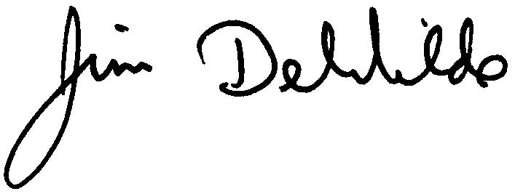

Jim DeWilde
WSASEA President
WSASEA

Washington State Association of Student Employment Administrators

Collectively addressing post-secondary student employment issues since 1979
http://www.ups.edu/professionalorgs/wsasea/

2002-2003 Town Meeting

Date: | Friday, October 25th
Time: | 10:00 a.m. to 3:00 p.m.
Location: | Central Washington University, Ellensburg, WA  Samuelson Union Building 204/205
Cost: | Free to WSASEA members, $15 for non-members. Payments are accepted at the door. With membership dues priced at $25, why would you not join?
Driving Directions: | http://www.cwu.edu/directions.html
Parking: | A daily permit can be purchased for $2.00 from dispensers located in lots G-16, W-12S, P-8, O-5, O-19, and C-9. A parking lot map is available at http://www.cwu.edu/~parking/map.pdf.  Free parking with a short walk is also available. See a map at  http://www.cwu.edu/~parking/
CWU Campus Map: | Available at http://www.cwu.edu/~seo/maps/
Membership | Visit our website at www.ups.edu/professionalorgs/wsasea/about.htm to obtain to our WSASEA membership form. Join today!

Town Meeting Agenda

10:00-10:20 am | Call to Order, Introductions, Minutes, Treasurer’s Report, and Housekeeping
10:20 - 11:05 am | Higher Education Coordinating Board Update
11:05 - 11:15 am | Break
11:15 - 12:15 pm | U.S. Department of Education Update
12:15 - 1:15 pm | No-Host Lunch
1:15 - 2:30 pm | INS Presentation on I-9 Forms & Employment Eligibility Verification
2:30 - 2:35 pm | Break
2:35 - 3:00 pm | Round Table Discussion
3:00 - 3:15 pm | New Comer Q&A
WSASEA

Washington State Association of Student Employment Administrators

Collectively addressing post-secondary student employment issues since 1979
http://www.ups.edu/professionalorgs/wsasea/

Annual Town Meeting Registration
Friday, October 25, 2002
Central Washington University, Samuelson Union Building 204/205

Join your colleagues, peers, and friends at the Town Meeting. Register to attend to ensure that we can accommodate each and every one of you. The Town Meeting is a free event for WSASEA members. Nonmembers may attend for a nominal registration fee of $15.00. See you there!

Name: |  | Title:
Department: |  | School:
Address: |  | City, State, Zip
Phone: |  | Fax:
Email: |  | School Website:

First time attendee? Yes____ No____

What issues or themes would you like to discuss during the roundtable session?

Any ADA accommodative materials required?

Town Meeting Fee – Check appropriate selection:

Current WSASEA members, free
WSASEA membership renewal for 2002-2003, or new member application, $25.00
Non-member registration fee, $15.00

Please make your check payable to WSASEA and send along with this form to:

Bob Yohnka, WSASEA Treasurer
Student Employment Coordinator
Seattle Pacific University
3307 3rd Avenue W
Seattle, WA. 98119-1997

