WSASEA

Washington State Association of Student Employment Administrators

Collectively addressing post-secondary student employment issues since 1979
http://www.ups.edu/professionalorgs/wsasea/

October 17, 2002

Dear Student Employment Administrator:

As a reminder, our Fall 2002 WSASEA Town Meeting is scheduled for Friday, October 25, 2002, at Central Washington University in Samuelson Union Building 204/205. Last week we sent out a Town Meeting information and registration packet. If you need a copy of the packet, please give me a call. The information is also available on our website at http://www.ups.edu/professionalorgs/wsasea/town_meeting.htm.

I encourage you to attend the Town Meeting to take advantage of a unique training opportunity. INS Agent Lynda Buehring will present information on the I-9 form, the Employment Eligibility Verification process, and reducing institutional liability in audit situations. The Town Meeting also includes State and Federal update sessions relative to student employment issues. Since the last mailing the meeting agenda, shown below, is adjusted to fit scheduling needs.

Town Meeting Agenda

10:00-10:20 am | Call to Order, Introductions, Minutes, Treasurer’s Report, and Housekeeping
10:20 - 11:05 am | Higher Education Coordinating Board Update, Betty Gebhardt
11:05 - 11:15 am | Break
11:15 - 12:15 pm | U.S. Department of Education Update, Linda Burkhardt
12:15 - 1:15 pm | No-Host Lunch
1:15 - 2:30 pm | INS Presentation on I-9 Forms & Employment Eligibility Verification, Lynda Buehring
2:30 - 2:35 pm | Break
2:35 - 3:00 pm | Round Table Discussion
3:00 - 3:15 pm | New Comer Q&A

The Town Meeting is a free event for WSASEA members. Nonmembers may attend for a nominal registration fee of $15.00. While advanced registration will help us plan for your attendance, you are welcome to register at the door. See you there!

Sincerely,
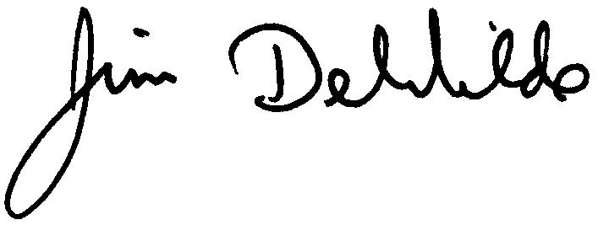

Jim DeWilde
WSASEA President
Center for Student Work Experience, WWU
(360) 650-3158

